



|  |  |  |
| --- | --- | --- |
|  |  |  |
|  | *xJ* |

Cl Cl Cl Cl Cl Cl Cl Cl



CI CI Cl l CI CI CI

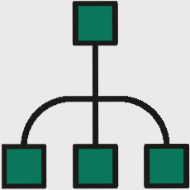



## We are delighted to have designed this business plan for you, an essential tool for formalizing your business project.

## .

This business plan template, provided by Crédit Agricole, details all the components of a business start-up or takeover project.

Take your time to think about it, and add to it regularly as you develop your project.

Don't hesitate to ask for help in drawing it up,

With the advice of a support network, your chartered accountant, etc**.**

It is on the basis of this document that all your partners (banks, investors, associates, etc.) will be able to assess the financial, economic and commercial structure of your project and evaluate its viability. and commercial aspects of your project and assess its viability.

# Overview of my project ____________________________________4

**MY MARKET______________________________________5**

* **The target market**
* **The competition**
* **Our customers**
* **Target market share**

**MY PRODUCT AN MY SEVICES**°__________________________**11**

* Description of my product(s) and/or my service(s)
* **My competitive advantage**
* **Points to watch**
* **Industrial property**
* **Manufacturing (design & development)**

**MY MARKETING STRATEGY_________________________16**

* **Marketing positioning (response to customer needs)**
* **Commercial positioning (prices, promotions, etc.)**
* **Distribution**
* **Communication**
* **Medium-term strategy**

**MY ORGANISATION____________________________________18**

* **Legal Form**
* **The team**
* **My start-up needs**

**Overview of my project**

**With these 3 questions, you need to arouse the interest of potential investors, make them want to believe in your project and**

**then study the various points of your project in more detail in the following sections.**

**What is your project?**

**Why do you want to develop it?**

**Why will your project succeed?**

## 

## Market research gives you a better idea of the chances and conditions for the success of your project.

## Far from being the insurmountable mountain many entrepreneurs imagine, market research is above all a question of common sense. What do you want to sell?

## and to whom? How are you going to sell it? Who are your competitors? Are there any particular regulations in this market? Are there specific risks to insure? Is there a preferred location?

## Finding the answers to all these questions will give you the means to make the best choices for your business, right from the start.

## **The target market**

## **Key data on the market in which I am interested (present figures, studies, etc.)**

Economic, political, social, cultural, legal and technological factors linked to my market that have an influence on its future development

**.**



**Possible developments in this market and trends over the coming months or years**

Identified barriers to entry (regulatory, economic, financial or technological)



Competitive intensity in my market (strength of existing competitors and potential entrants, bargaining power of customers and suppliers, existence of substitute products)

|  |  |  |  |  |  |
| --- | --- | --- | --- | --- | --- |
| **Competitive**  **iintensity** | **Very strong** | **strong** | **Medium** | **Low** | **Very Low** |
| **Competitors** |  |  |  |  |  |
| **Potential entrants** |  |  |  |  |  |
| **Customers** |  |  |  |  |  |
| **Suppliers** |  |  |  |  |  |
| **Substitute products** |  |  |  |  |  |

## **Competition (List 2 direct or indirect competitors)**

|  |  |  |  |
| --- | --- | --- | --- |
| **Name of company** |  |  |  |
| **Localization** |  |  |  |
| **Description**  **(type of product...)** |  |  |  |
| **Brand image**  **Market positioning** |  |  |  |
| **Market share** |  |  |  |
| **Turnover** |  |  |  |



**My positioning in relation to my competitors (assets to highlight: product, brand, company, etc.)**

## **Our customers**

## **Presentation of my target customer(s) (professionals, private individuals, local authorities, etc.) and their contribution to my sales.**



**Main characteristics of my potential clientele (average expenditure, purchasing motivations, types of company, socio-professional categories, etc.)**

**Identified customer needs (What customer needs does your product or service meet?)**

**Estimate the number of customers, my catchment area...**

**Estimation du nombre de clients, de ma zone de chalandise…**



**Trend in recent years, current trend, future trend (increase, stagnation), change in expectations**

**Volume of consumption (quantity purchased expressed over a period of time) and the equipment rate of my customers (% of the population who own the product).**

## **Target market share**

**Estimate your market share in % and justify this figure.**

).



# s

## **Your research confirms that there is a market for your idea.** **Now it's time to build up your offer in detail and identify your costs.**

## **To build your commercial strategy and assess the viability of your project, you need to study all the key parameters of your future business.** **This means, for example, defining how you are going to design and develop your products or services, or identifying your potential suppliers and supply channels now.**

## **You should also think about the distribution method you envisage.** **This will determine your choice of premises, your potential partners and, overall, the construction of your business model.**

## **Finally, you need to identify your unavoidable costs.** **All these elements will enable you to make your first financial forecasts with a view to drawing up your business plan.**

## **Description of my product(s) and/or service(s)**

## **Technical characteristics, use, needs covered, product range...**

## **My competitive advantages**

**Characteristics of my business compared to my competitors (what are my strengths compared to my competitors?)**



## **My points of vigilance (finding potential threats to my business (regulations, competition, standards, economic context, etc.))**



**Industrial property (for companies wishing to protect an innovation or a**

**brand).**

**Registered patents, trademarks and licence**

|  |  |  |  |
| --- | --- | --- | --- |
|  | **Coverage area** | | |
| **registration** | **France** | **European Union** | **International** |
|  |  |  |  |
|  |  |  |  |
|  |  |  |  |
|  |  |  |  |

## **Manufacturing (design & development)**

## **How my product(s) are manufactured (in-house/subcontracted)**

**Local, equipment, production staff...**

**)**

**Type of production envisaged (series/one-off)**



**Coût direct de production**

Principaux éléments qui composent mon coût de production



**Marketing and sales positioning (based on the 4P and 4C)**

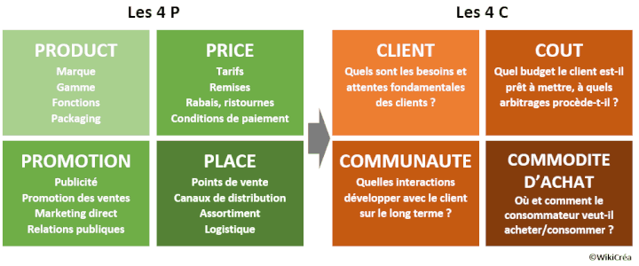

## https://www.jesuisentrepreneur.fr/activite/comment-choisir-bon-canal-distribution.html



**Commercial premises (location, cost, lease, frontage, opening hours, etc.)**

**Supply chain (intermediaries/purchasing centres, power relations, lead times, payment methods, financial strength)**

**https://www.jesuisentrepreneur.fr/activite/comment-choisir-vos-fournisseurs.html**

## **Communication**

**Communication actions planned (mailings, advertising, promotional actions, etc.)**

|  |  |  |
| --- | --- | --- |
| **Actions** | **Objectives** | **Budget envisaged** |
|  |  |  |
|  |  |  |
|  |  |  |
|  |  |  |
|  |  |  |



## **Medium-term strategy**

## **My vision for my company over 3 and 5 years**



**The legal form**

**The choice of legal form can have a major impact on both your business and your personal and family life.**

**To choose the legal structure best suited to your project, take into account not only your company's activity, your financial and family concerns, but also the image you wish to project of your company...**

**Take a look at the table comparing company statutes.**

[**https://www.jesuisentrepreneur.fr/statut-juridique/quel-statut-entreprise.html**](https://www.jesuisentrepreneur.fr/statut-juridique/quel-statut-entreprise.html)

**Choice of status**

**Choice of status**



## **The team**

**https://www.jesuisentrepreneur.fr/activite/comment-evaluer-vos-besoins-personnel.html**

**Organisation (descriptif des postes et des effectifs)**

**Workforce**

|  |  |  |
| --- | --- | --- |
| **Year of hire** | **Function Estimated cost** | |
| **First year** |  |  |
| **2nd year** |  |  |
| **3rd year** |  |  |

**Training courses**

|  |  |  |
| --- | --- | --- |
| **Skills to acquire** | **Profile** | **Cost** |
|  |  |  |
|  |  |  |
|  |  |  |
|  |  |  |



**Equipment needed to launch my business**

**https://www.jesuisentrepreneur.fr/activite/de-quoi-avez-vous-besoin-pour-fonctionner.html**

**furniture, fittings and work needed to launch my business**